- Some forecasters are more optimistic about UK growth prospects following the Budget, but we take the opposite view. Our outlook for 2025 is more cautious, shaped by four key themes:
- Fiscal sustainability concerns will linger. The UK's debt dynamics are among the worst of the advanced economies, and higher market interest rates have already eaten some of the headroom against the fiscal rules. The Chancellor will come under pressure to implement further tax hikes.
- Tight policy settings will weigh on activity. Though the Budget lessened the squeeze, fiscal policy will still tighten significantly in this parliament, with much of the impact in the next couple of years. Net household interest payments will continue to rise as mortgagors refinance cheap fixed-rate deals, even though Bank Rate is likely to be gradually cut.
- Trump's tariffs will have a limited impact. We expect US tariff increases to be targeted and the UK is unlikely to be directly affected. But even if the US imposed large across-the-board tariffs, the impact on UK growth and inflation would be limited.
- UK asset prices may continue to carry a high risk premium. Looser fiscal rules and a more volatile inflation outlook imply a higher nominal neutral interest rate. But the risk premium on the front end of the yield curve looks excessive. The UK's long-running growth under-performance and fiscal sustainability concerns mean we expect the term premium will remain elevated.
The UK economy ends 2024 at a crossroads. After a surprisingly strong H1 2024, GDP growth almost ground to a halt in Q3. Meanwhile, many forecasters – including the Office for Budget Responsibility and the Bank of England – have become more optimistic about prospects for 2025, arguing the large rise in day-to-day government spending announced in the Budget will cause demand to surge.
We agree that the Q3 outturn should prove to be noise rather than the start of a sustained slowdown, however we think the chances that the economy accelerates to a 2% growth pace in 2025 are low. The UK has several long-running structural problems to solve and there's much the new government needs to do.
Chart 1: The UK's debt dynamics are among the most challenging of the advanced economies
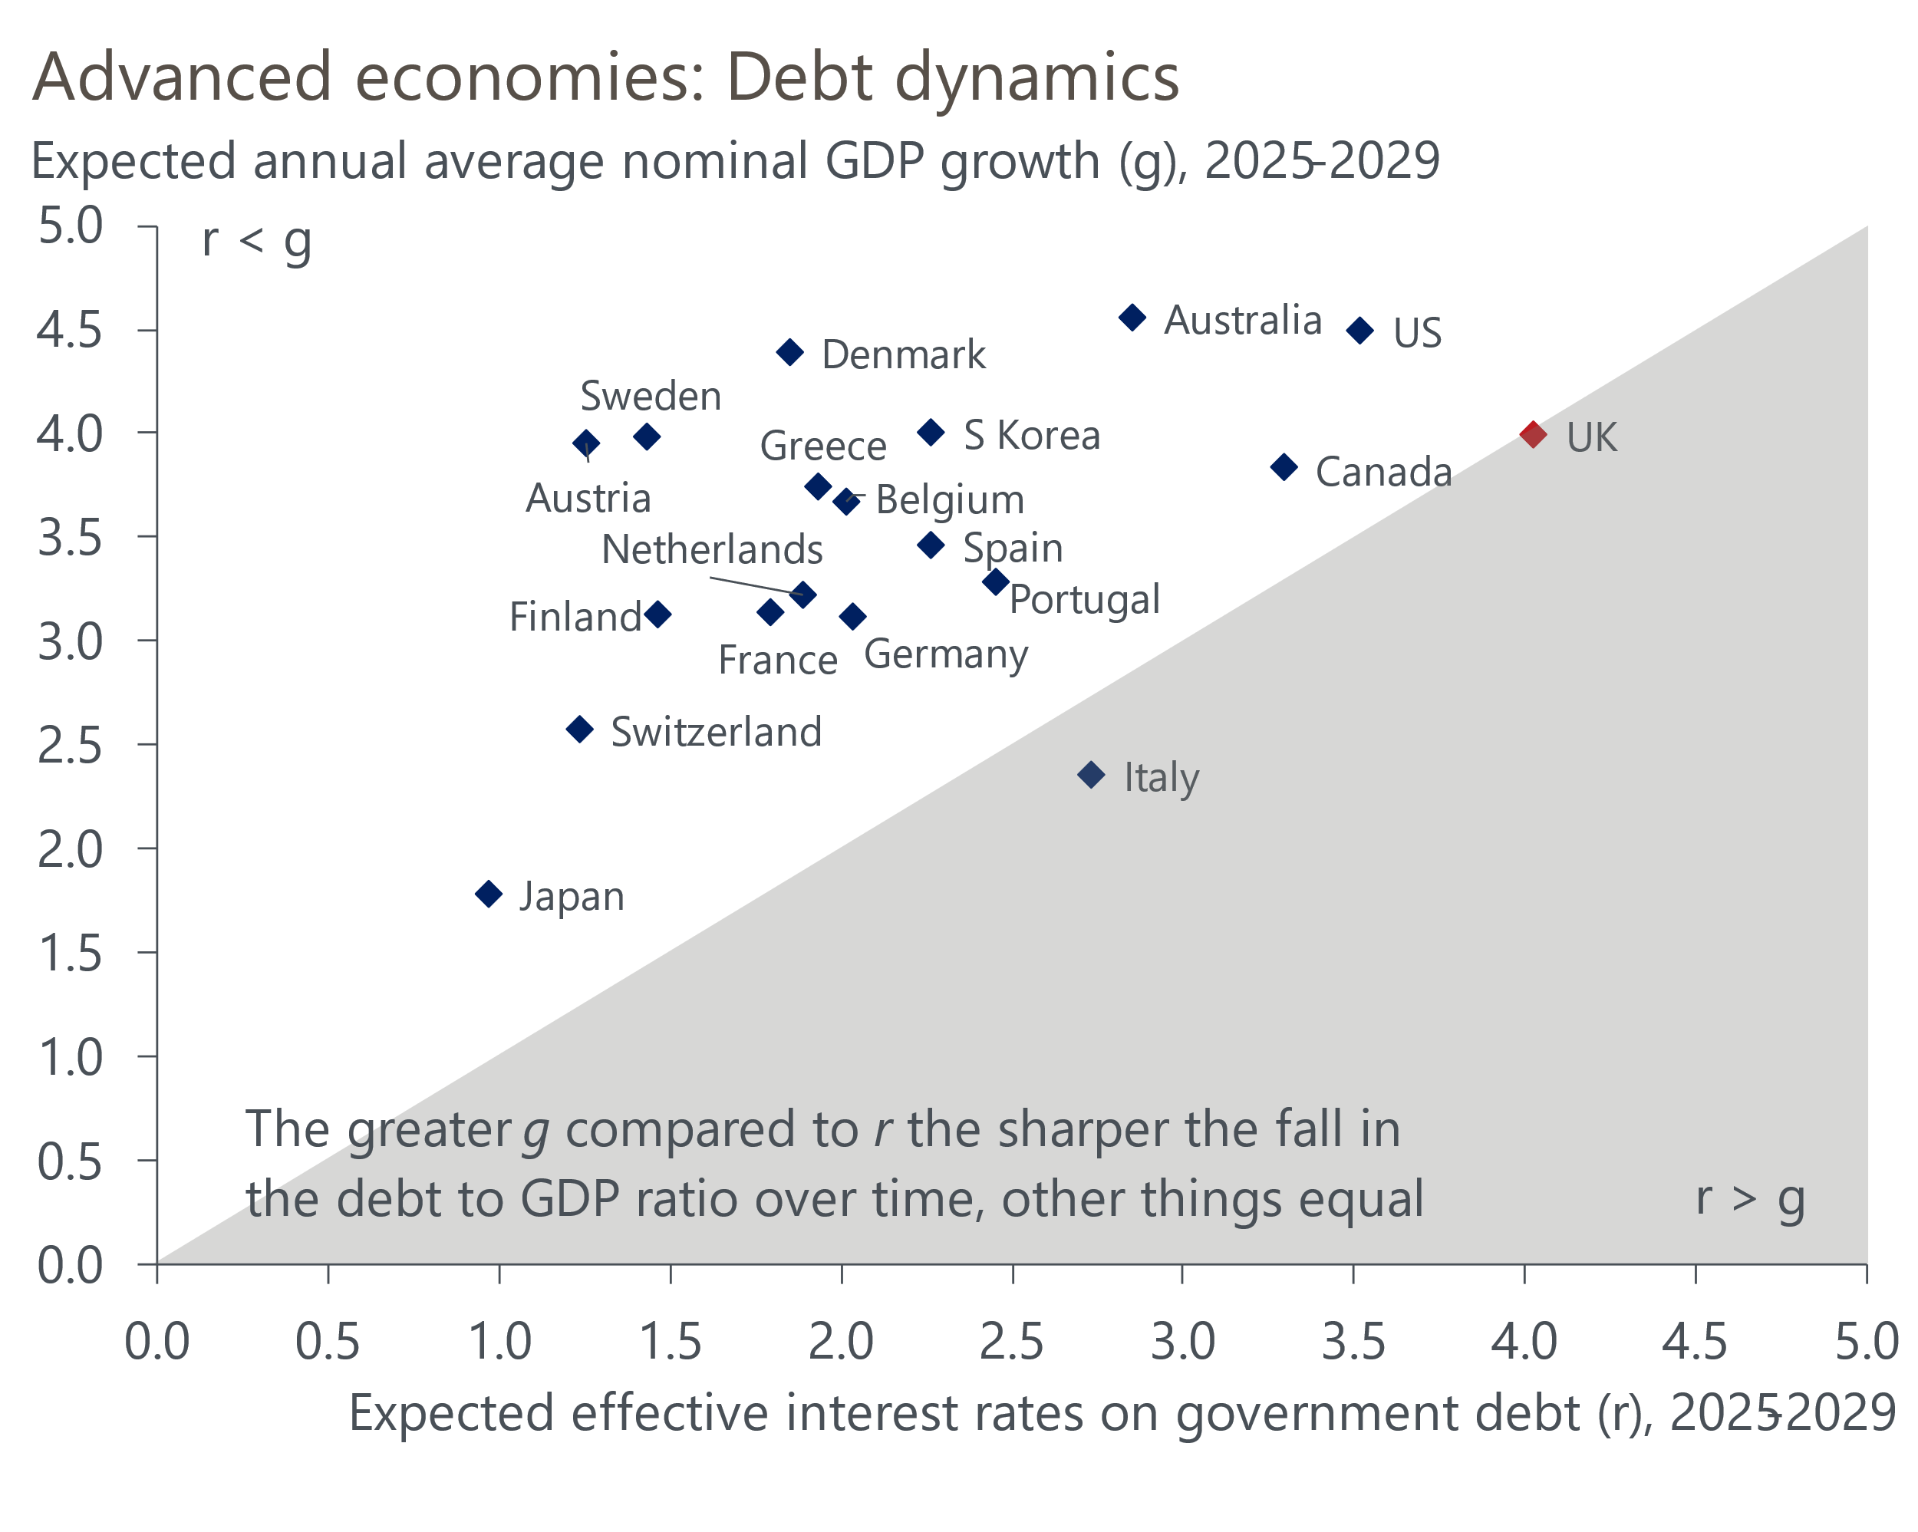
Source: Oxford Economics

Theme 1: Fiscal sustainability concerns will linger
We've been critical for some time of the state of the UK's public finances and the role played by poorly designed fiscal rules in getting to that position. In particular, a series of tweaks had resulted in rules that imposed scant debt discipline while also discouraging government investment and, therefore, dampening prospects for economic growth.
October's Budget was a step in the right direction. The new rules – targeting a balanced current budget (i.e., day-to-day spending matched to government revenue) and a falling ratio of public sector net financial liabilities to GDP – are more investment-friendly. The shortened forecast horizon for those rules – eventually moving to three years from five – should also help to bolster the credibility of the new framework. And by replacing implausibly tight spending assumptions with specific tax hikes, the proposed consolidation looks more credible than before.
But the Chancellor undermined some of that good work with other decisions that damaged market confidence. The government had spent months preparing the ground for looser rules and more borrowing, but the size of the package was larger than markets had been led to believe. The government's rhetoric had centred on borrowing to invest, but a third of the extra borrowing was to fund higher day-to-day spending. And by choosing not to index fuel duty in her first Budget, the Chancellor has cast doubt on whether future fiscal plans – which include raising the level of fuel duty in subsequent years – are credible. The Chancellor also left very little headroom to guard against future shocks.
We think this last issue is likely to mean that concerns about fiscal sustainability stay to the fore in 2025. There are several plausible scenarios that could cause the OBR to revise its forecasts so that the wafer-thin headroom is eliminated. If gilt yields and market expectations for Bank Rate remain at their current level, it would remove around a quarter of the headroom. The OBR's medium-term potential output forecasts are above consensus and vulnerable to being revised down if growth continues to disappoint.
The spring 2025 spending review will also force the government to turn spending totals into department-by-department allocations. Calculations by the OBR suggest that totals assumed in the Budget would mean real terms spending cuts for unprotected departments. So there's likely to be pressure on the Chancellor to increase the size of the envelope. And even if she doesn't increase total spending, markets are likely to be sceptical that such tight plans will be adhered to.
We forecast average nominal GDP growth will be roughly equal to the effective interest rate the UK government will pay on its debt over the course of this parliament. Of the advanced economies, only Italy is in a worse position (Chart 1). To avoid worsening this situation, the Chancellor may need to raise taxes again in 2025, perhaps as soon as next spring's fiscal event if movements in market pricing further erode the Chancellor's headroom.

Theme 2: Tight policy settings will weigh on activity
Much of the media commentary around the Budget focused on the fact that policy was being loosened relative to the plans inherited from the previous government. But this ignores the fact that the previous plans assumed a large tightening of fiscal policy. Moreover, those plans required a prolonged period of spending restraint which looked implausible.
We calculate that the new plans still imply substantial fiscal tightening of 0.7% of potential GDP in 2025-2026 (Chart 2). This would be comparable to the most restrictive years of the 2010-2015 austerity programme. Moreover, implausible spending cuts have been replaced by specific tax hikes. The bulk of the revenue increase will come from higher employer national insurance contributions, with the cost likely to be reflected in lower headcount, weaker wage growth, higher inflation, and lower profitability. This will dampen the outlooks for consumer spending and business investment, increasing the onus on the public sector to drive growth next year.
Chart 2: Fiscal policy will get progressively tighter, despite the Budget announcements
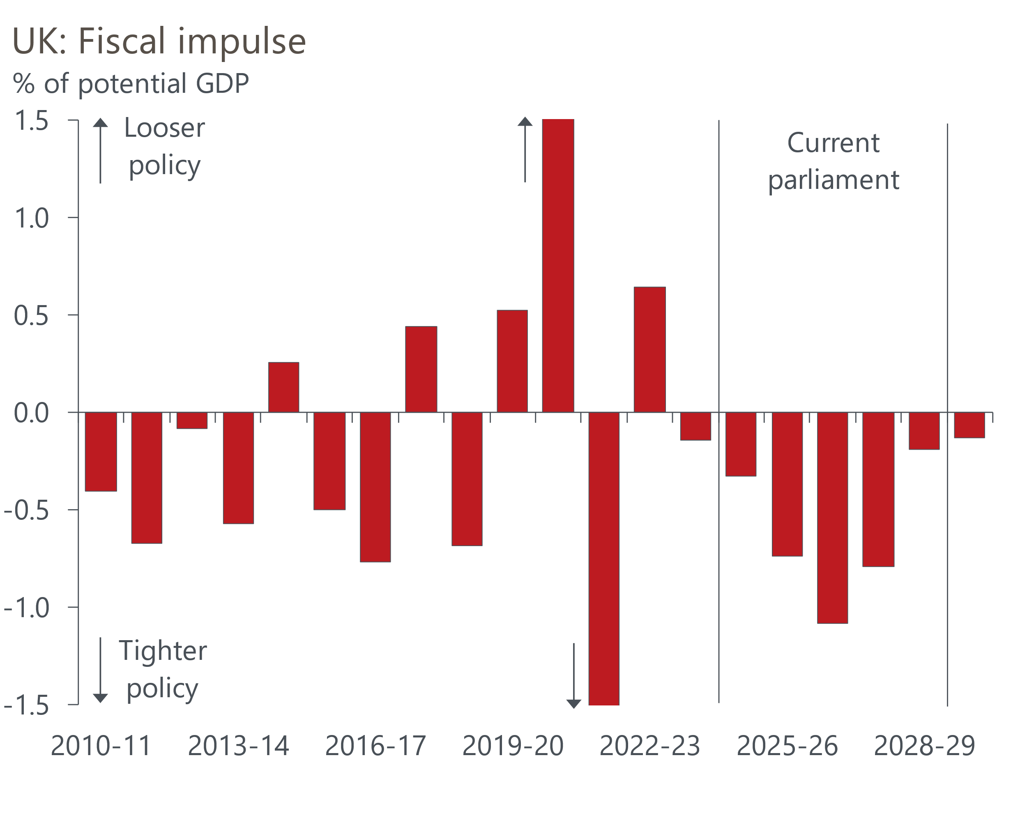
Sources: Oxford Economics, Haver Analytics
It's a similar story with respect to the impact of monetary policy on growth prospects. Though we expect the BoE's Monetary Policy Committee to continue to gradually cut the policy rate next year, the lagged impact of the 2022-2024 hiking cycle is likely to dominate.
The experience of the recent hiking cycle suggests that rate cuts should be transmitted to corporate interest rates relatively quickly. Most corporate debt is floating rate or fixed at short maturities, so companies should see their debt servicing costs drift downwards next year.
But it's a very difference picture for the household sector. Of outstanding mortgage debt, just 12% was on a floating rate in Q3 2024, with more than 60% having initially been fixed for at least five years. Data from the Financial Conduct Authority suggests around 1mn mortgagors will need to refinance fixed-rate deals that expire in 2025. Many of those borrowers will be refinancing expiring five-year fixes, and they face an uplift in their interest rate of around 250bps (Chart 3).
Chart 3: Many mortgagors face refinancing at much higher interest rates in 2025
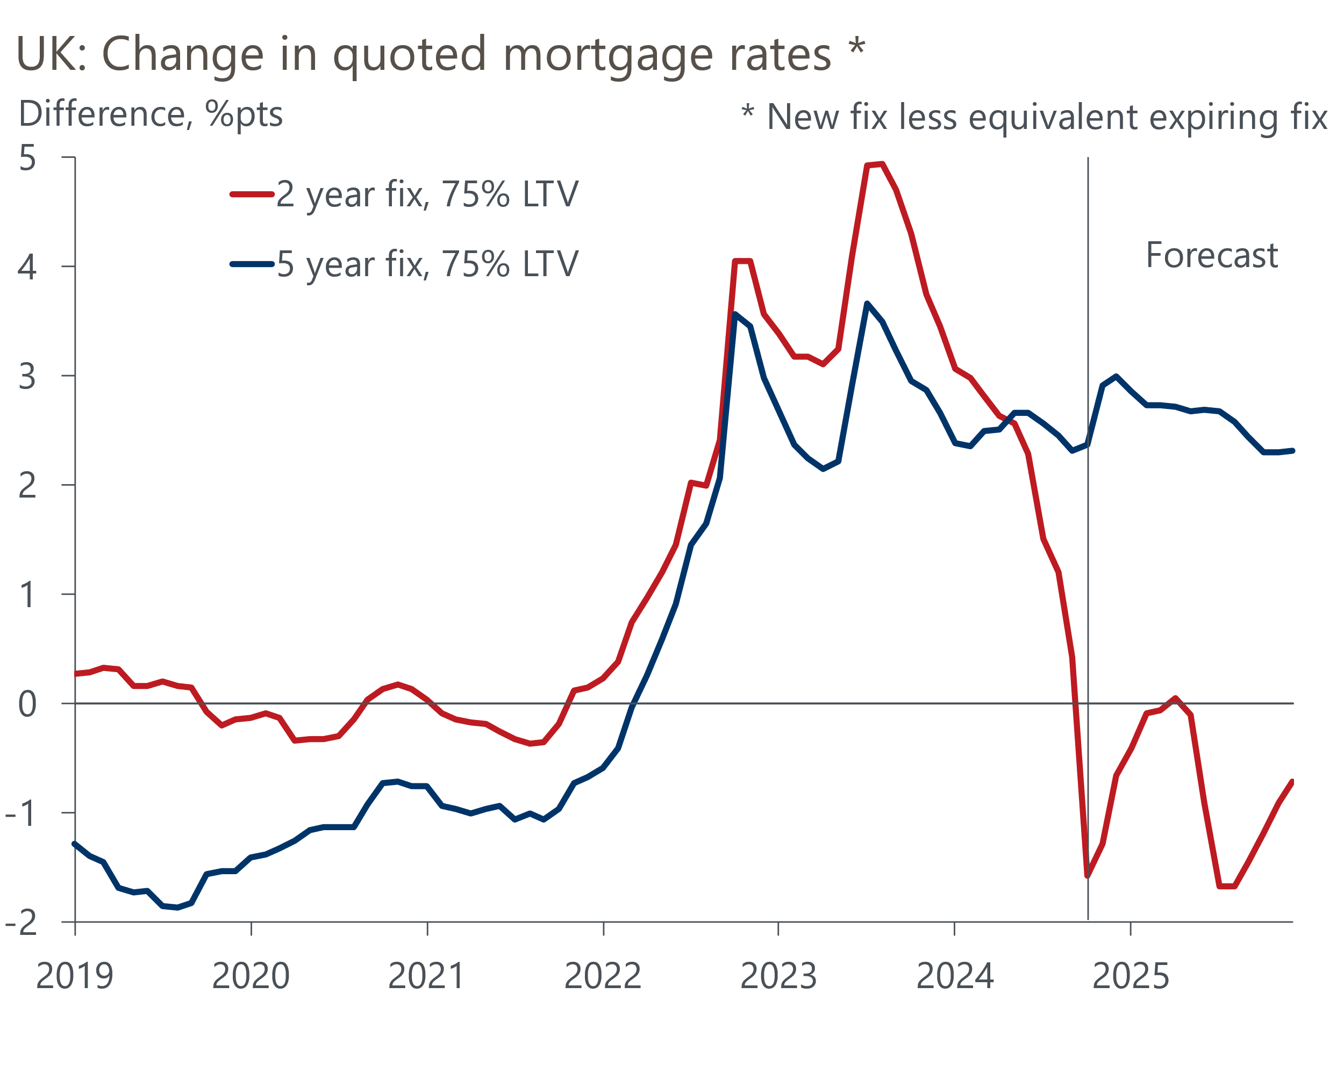
Sources: Oxford Economics, Haver Analytics
As a result, we expect the average interest rate on outstanding mortgages will continue to edge up during 2025. At the same time, cuts to Bank Rate are likely to drive down interest rates on deposits. So the net interest position of households will deteriorate, weighing on incomes.
Moreover, even though Bank Rate will be coming down, its level will still be relatively high and above most plausible estimates of neutral. For example, the BoE Market Participants Survey suggests a neutral interest rate is 3.25%-3.5%, and our estimates suggest it may be even lower. So monetary policy will probably still be restrictive during 2025.
With fiscal policy becoming more restrictive and the lagged impact of previous rate hikes dominating, we think even trend growth of around 1.5% might prove a challenge. The OBR's forecast of 2% growth looks a big stretch, particularly if – as we expect – the boost to real government consumption falls short of the OBR's very bullish expectations.
Policy settings also have important implications for credit quality. On the corporate side, though debt servicing costs should steadily fall, firms have the increase in NICs and a 6.7% rise in the national living wage (NLW) to deal with from April. Companies may be able to pass on some of the increase in costs through higher prices, and many will seek to cut labour costs via smaller pay rises or lower headcount. But it's likely that profitability will be hit. The large cut in the threshold for paying NICs and the big increase in the NLW represent particular problems for low-paying, labour-intensive sectors such as retail and hospitality. So corporate insolvencies are likely to remain relatively high. With regard to households, large increases in mortgage payments for borrowers refinancing cheap fixed-rate deals could keep levels of arrears elevated.

Theme 3: Trump's tariffs will have a limited impact
In the weeks since Donald Trump's US election victory there's been much media speculation about how the president-elect will implement his core policy pledge to impose tariffs on US imports. We think legal obstacles make across-the-board tariffs unlikely, and we expect the US to pursue a targeted approach. The new administration is likely to focus on countries that enjoy large trade surpluses with the US, that impose large tariffs on imports from the US, and whose tariffs have a material impact on US jobs. Based on these criteria, the UK is likely to be well down the list of priorities for Trump.
The situation is unlikely to be resolved quickly, so UK firms that are heavily reliant on exporting to the US will face a prolonged period of uncertainty. This will be damaging for confidence and, coming alongside the impact of the NICs increase, means a relatively soft outlook for business investment in 2025. But the impact on the UK should be offset by stronger global demand, stoked by looser US fiscal policy.
Even if Trump follows through on his campaign rhetoric and imposes large across-the-board tariff increases, we think the macroeconomic impact would be limited. Our 'full-blown Trump' scenario assumes across-the-board tariffs of 10% on all goods imported into the US and 60% tariffs on imports from China, raising the average US tariff to a level last seen in the 1930s. It also assumes US fiscal policy is more aggressive than in our baseline forecast and curbs on immigration are higher. As with the baseline, we assume that it takes time for higher tariffs to be implemented. We also assume full retaliation by other countries, including the UK.
This scenario shows a peak impact on UK GDP of 0.2ppts, with prices rising 0.3ppts above the baseline (Chart 4). Furthermore, retaliation by the UK is responsible for a large part of the increase in inflation. But we think it's far from given that the UK would hit back in this situation. The UK has a much heavier reliance on goods imported from the US than the other way around, suggesting that retaliation would be self-defeating. So the impact could turn out even smaller than we estimate.
Chart 4: Even the most extreme Trump scenario would have a limited impact on UK GDP and prices
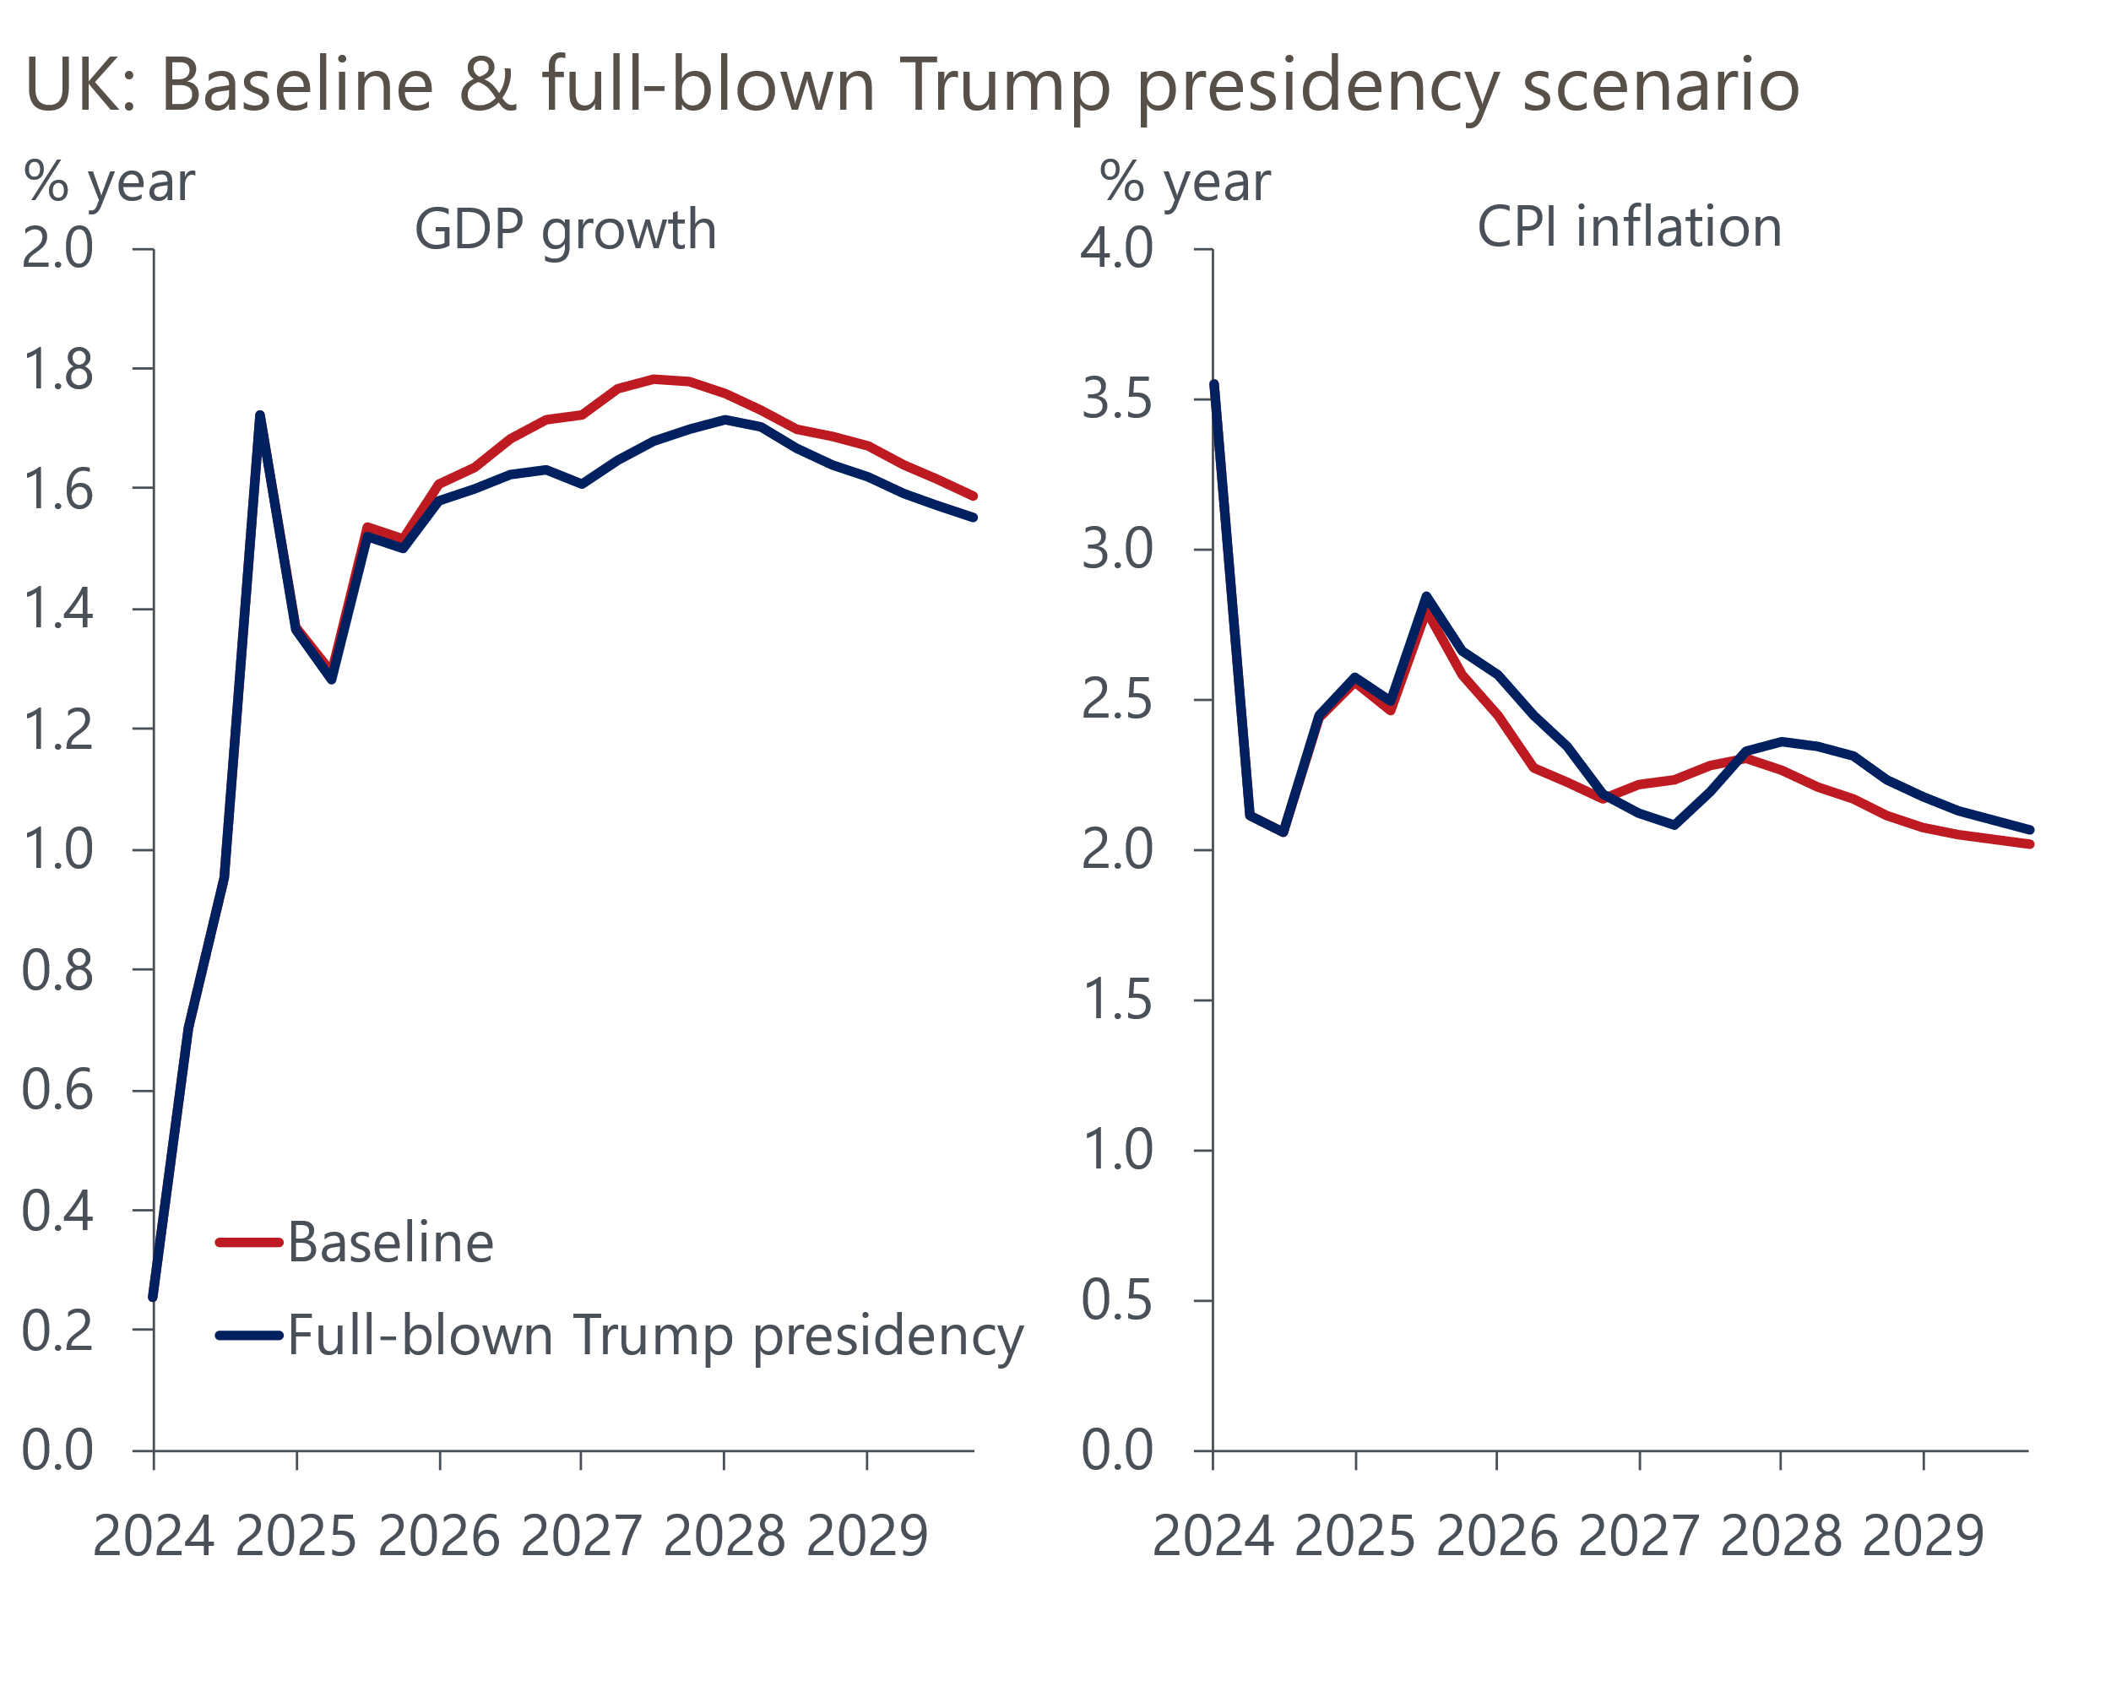
Sources: Oxford Economics, Haver Analytics

Theme 4: UK asset prices may continue to carry a high risk premium
Financial markets have taken a hawkish view of the implications of the UK Budget and Trump's US election victory. Market pricing now implies a terminal Bank Rate of around 3.75%, up from 3.5% in mid-October (Chart 4). At the longer end of the curve, 10-year gilt yields are up around 30bps over the same period.
Chart 5: Looser UK fiscal policy and Trump's victory have raised the likely terminal Bank Rate
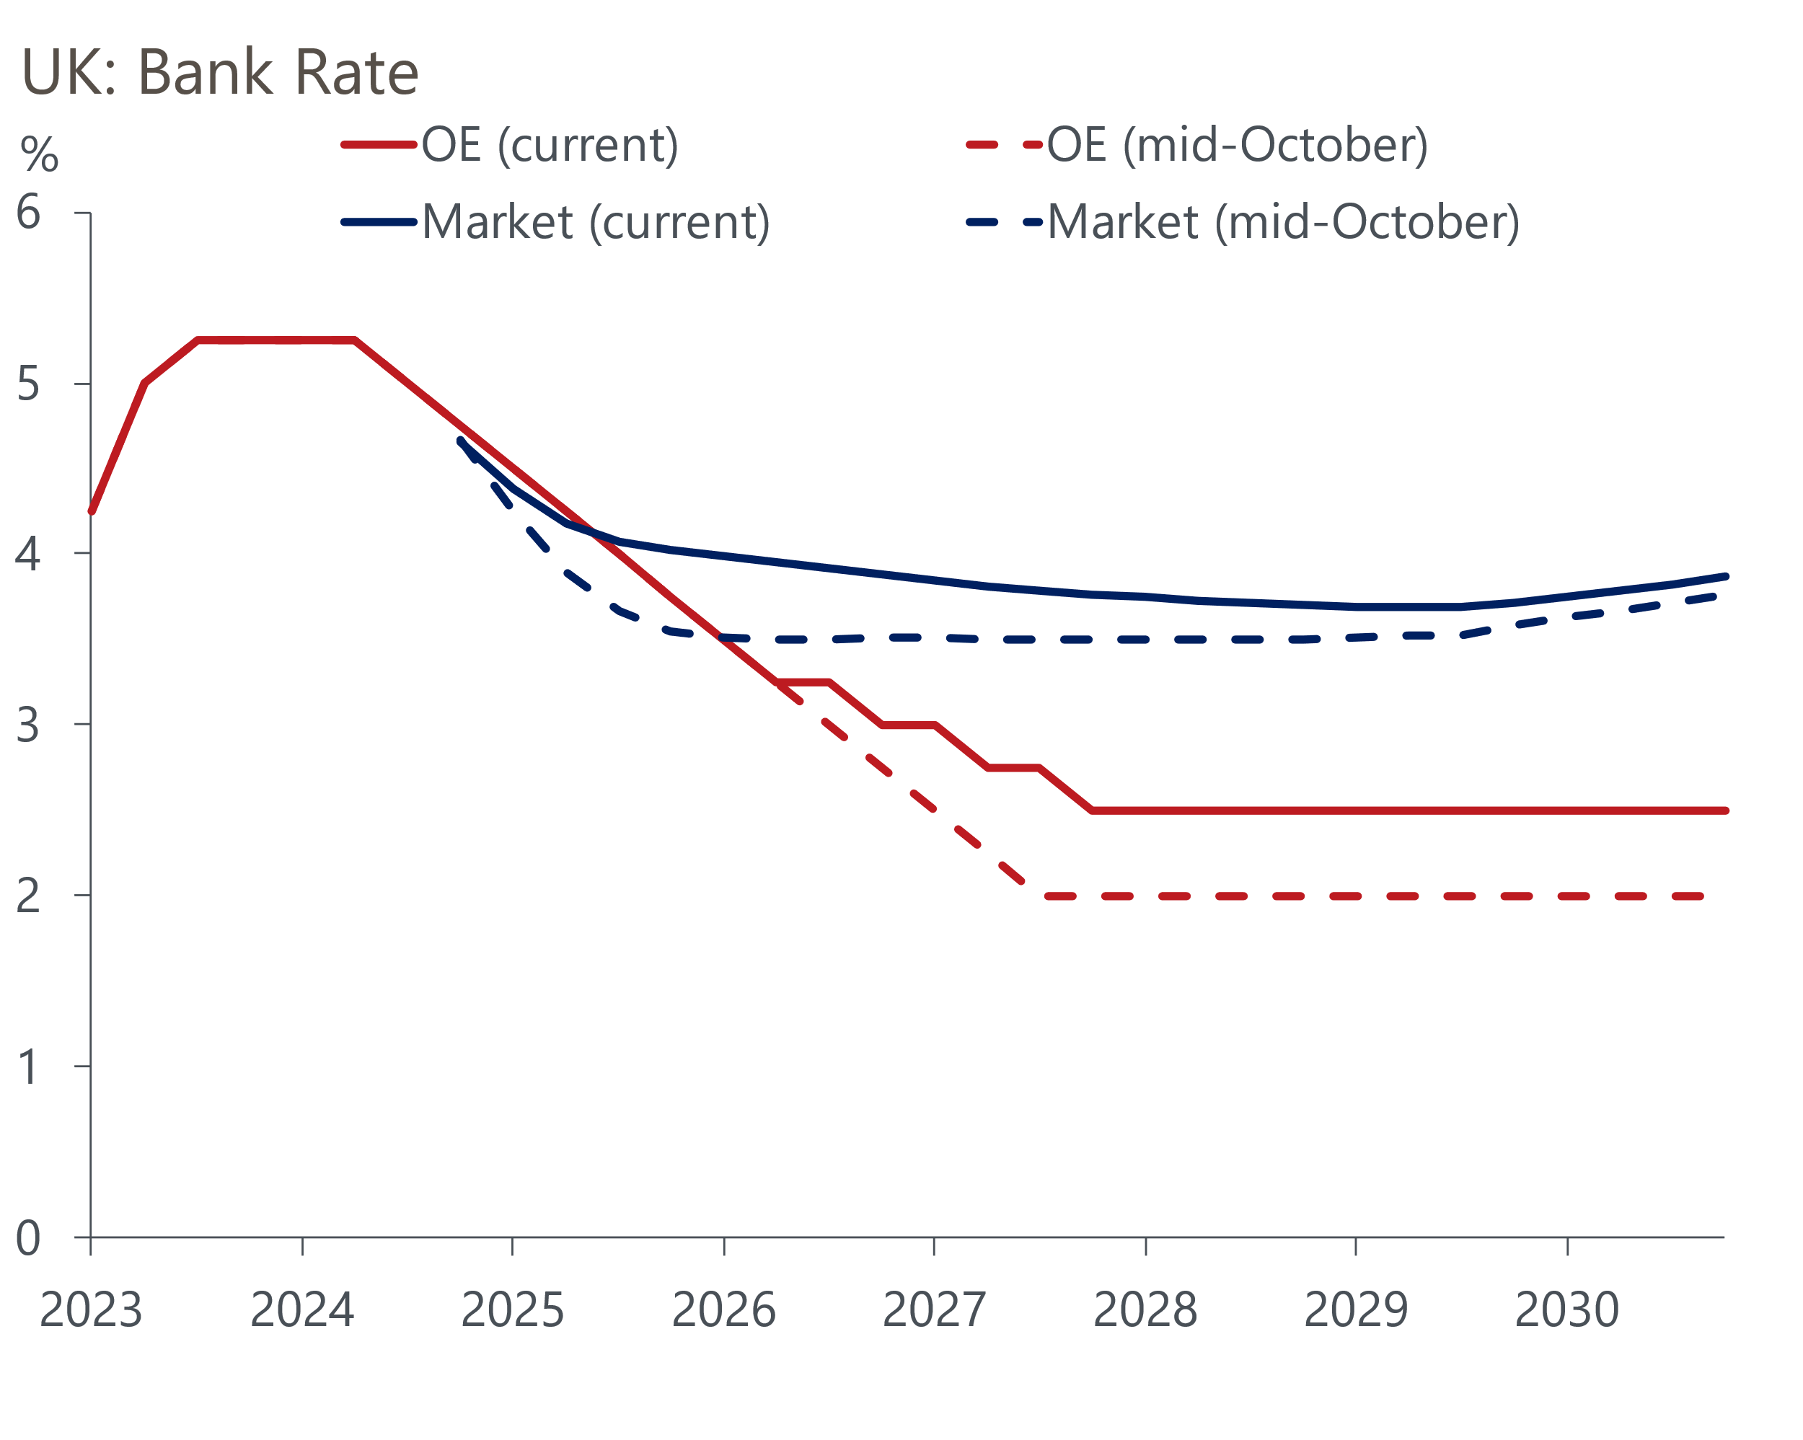
Sources: Oxford Economics, Haver Analytics
Using our framework for estimating neutral interest rates, we've recently raised our long-term forecasts for Bank Rate and gilt yields by 50bps. Adopting less restrictive fiscal rules and running higher deficits means that government debt is likely to be higher than we previously forecast. This is consistent with a higher real neutral interest rate. Meanwhile, prospective US policy changes imply higher inflation expectations globally.
These changes took our long-run Bank Rate forecast to 2.5%, with 10-year gilt yields projected to settle at 3.35%. These forecasts are well below the levels implied by current market pricing. If we're right, it may take some time for markets to adjust fully, with the question of the level of the terminal rate only coming into sharper focus once Bank Rate is a lot closer to where markets think a neutral level might be. Nevertheless, if (as we expect) pay growth and services inflation drop closer to target-consistent rates in 2025, then the risk premium in front-end rate expectations probably will decline in 2025.
We think the term premium will remain elevated. US policy changes mean high term premia are likely to be a feature across the world. But there's several domestic factors that suggest investors will remain wary about the UK specifically (Chart 6).
Chart 6: UK term-premium is likely to remain elevated in 2025
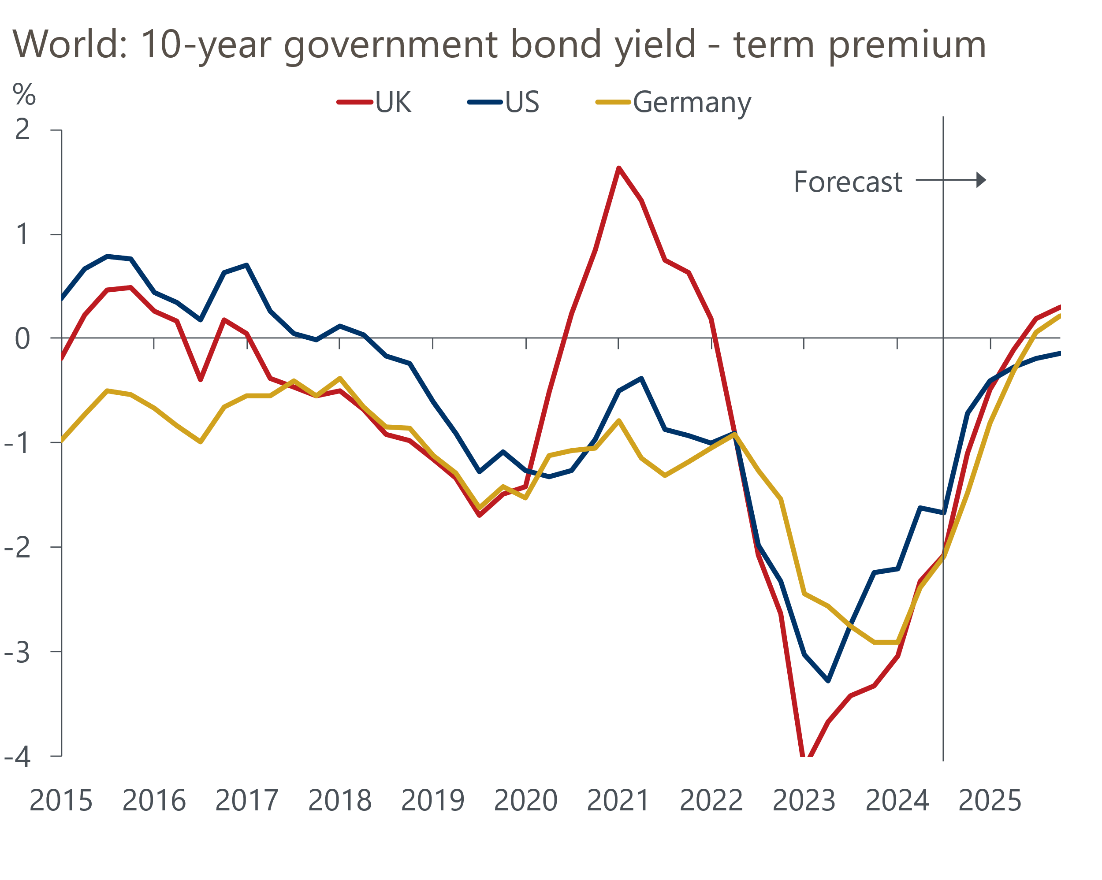
Sources: Oxford Economics, Haver Analytics
The market has to absorb a lot of extra gilt issuance as a result of the much higher borrowing plans announced in the Budget, with a lot of that extra supply coming at the medium- and long-end. As we've established, concerns about fiscal sustainability are unlikely to go away. Furthermore, the government is yet to offer detailed policies that might convince markets that it can orchestrate a recovery from the dismal productivity performance that has now lasted almost two decades.
More broadly, a more stable political backdrop should theoretically support sentiment around UK assets, after the turbulence of recent years. But the new Labour administration has had a relatively rocky start. And markets will want to see more tangible evidence that the government is getting a grip on the many structural problems it has inherited before they are willing to give the UK the benefit of the doubt.

